Exercise 1: Create a Stored Procedure
Goal: Create a stored procedure to retrieve employee details by department.
Steps:
1. Define the stored procedure with a parameter for DepartmentID.
2. Write the SQL query to select employee details based on the DepartmentID.
3. Create a stored procedure named `sp_InsertEmployee` with the following code:
CREATE PROCEDURE sp_InsertEmployee
@FirstName VARCHAR(50),
@LastName VARCHAR(50),
@DepartmentID INT,
@Salary DECIMAL(10,2),
@JoinDate DATE
AS
BEGIN
INSERT INTO Employees (FirstName, LastName, DepartmentID, Salary, JoinDate)
VALUES (@FirstName, @LastName, @DepartmentID, @Salary, @JoinDate);
END
CREATE DATABASE EmployeeDB;
USE EmployeeDB;
CREATE TABLE Departments (
DepartmentID INT PRIMARY KEY,
DepartmentName VARCHAR(100)
);
CREATE TABLE Employees (
EmployeeID INT AUTO_INCREMENT PRIMARY KEY,
FirstName VARCHAR(50),
LastName VARCHAR(50),
DepartmentID INT,
Salary DECIMAL(10,2),
JoinDate DATE,
FOREIGN KEY (DepartmentID) REFERENCES Departments(DepartmentID)
);
INSERT INTO Departments (DepartmentID, DepartmentName)
VALUES
(1, 'HR'),
(2, 'Finance'),
(3, 'IT'),
(4, 'Marketing');

INSERT INTO Employees
(FirstName, LastName, DepartmentID, Salary, JoinDate)
VALUES
('Satya', 'Gowri', 1, 5000.00, '2020-01-15'),
('Sumana', 'Sakhamuri', 2, 6000.00, '2019-03-22'),
('Divya', 'Chinta', 3, 7000.00, '2018-07-30'),
('Renuka', 'Tadepalli', 4, 5500.00, '2021-11-05');

SELECT * FROM Departments;
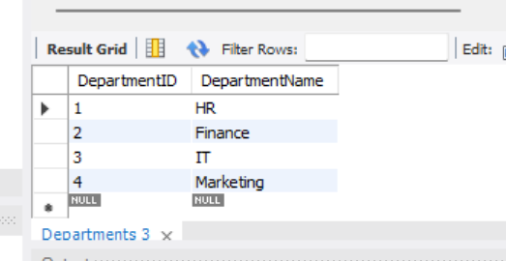
SELECT * FROM Employees;
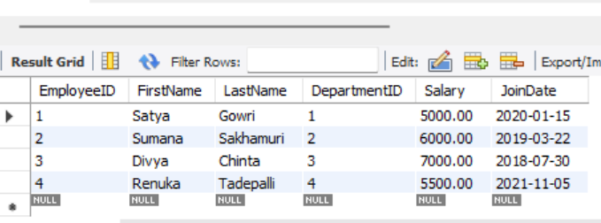

DELIMITER $$
CREATE PROCEDURE sp_GetEmployeesByDepartment(IN p_DepartmentID INT)
BEGIN
SELECT
EmployeeID,
FirstName,
LastName,
DepartmentID,
Salary,
JoinDate
FROM Employees
WHERE DepartmentID = p_DepartmentID;
END $$

DELIMITER ;
CALL sp_GetEmployeesByDepartment(1);
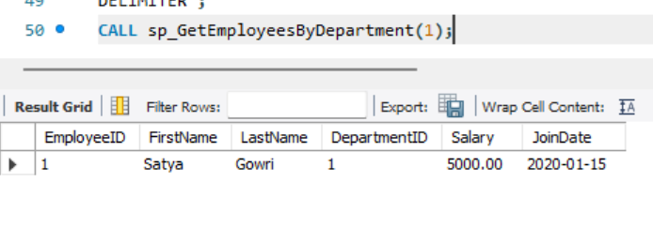

CREATE PROCEDURE sp_InsertEmployee(
IN p_FirstName VARCHAR(50),
IN p_LastName VARCHAR(50),
IN p_DepartmentID INT,
IN p_Salary DECIMAL(10,2),
IN p_JoinDate DATE
)
BEGIN
INSERT INTO Employees
(FirstName, LastName, DepartmentID, Salary, JoinDate)
VALUES
(p_FirstName, p_LastName, p_DepartmentID, p_Salary, p_JoinDate);
END $$

DELIMITER ;
CALL sp_InsertEmployee(
'Bhavya',
'Guduru',
3,
6500.00,
'2022-06-15'
);
